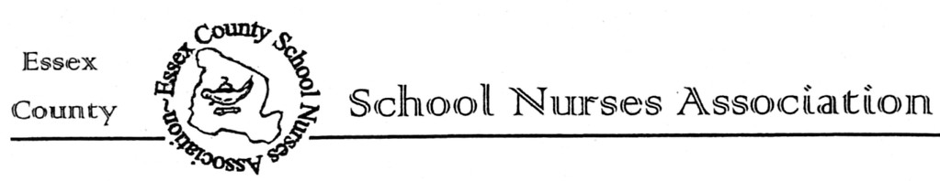
COVID-19 Burnout and Returning to Work Training
With Frankie Mallis, MA, CSW from HealthCare Assistance and Member Support,HCAMS
Frankie Mallis, M.A., CSW is an adjunct professor at Arcadia University. She led organization efforts with United Academics of Philadelphia to unionize all of the adjunct professors in 2016 after winning Adjunct Professor of the Year. A graduate of Cornell University, she became a social worker before earning her Master’s. Frankie is deeply committed to mindfulness, and wellness practices, and sharing them with others. She earned her 200 hour RT yoga certification in 2015.
Your Union’s Employee Assistance Program
In this Back to School Practices Training, we will:
- We’ll assess where we stand on the COVID Burnout Scale.
- Cover the Families First Coronavirus Response Act.
- Learn and practice mindfulness techniques proven to relieve stress and anxiety.
Join us via Zoom Wednesday, September 16, 4PM
*This program is offered free of charge and can be accessed through the “Events” page of the new ecsna.org website or using the information below:
Zoom Meeting ID:84093852422
Passcode:114096
HealthCare Assistance with Member Support (HCAMS) offers members the medical services they require to access care and mitigate discipline. HCAMS provides job protective services and support for behavioral health and substance abuse issues to you and your family at no cost. This is a confidential program available 24/7.
www.unionsupport.org
1-888-828-7826
HCAMS, Your Union’s EAP

